## 

## PROJECT REPORT

**ON**

**“****AI THERAPIST USING CBT MODULE AND DNN ALGORITHM”**

## SUBMITTED IN PARTIAL FULFILLMENT OF THE REQUIREMENTS OF DEGREE OF

**BACHELOR OF ENGINEERING**

**BY**

**ROHAN LOKHANDE [26] AMEY POTE [47]**

**SURUCHI REVANDKAR [49]**



**Department of Computer Engineering**

**Pillai HOC College of Engineering and Technology, Rasayani, Pillai’s HOC Educational Campus, HOCL Colony,**

**Rasayani, Tal: Khalapur, Dist Raigad-410207 UNIVERSITY OF MUMBAI**

**[2020-21]**

**Mahatma Education Society’s**

**Pillai HOC College of Engineering and Technology, Rasayani-410207**

**2020-2021**



**CERTIFICATE**

This is to certify that the project entitled **“AI Therapist**” is a bonafide work of **“Rohan Lokhande, Amey Pote, Suruchi Revandkar”** submitted to the University of Mumbai in partial fulfilment of the requirement for the award of the degree of **“Undergraduate”** in **“Computer Engineering”**.

DECLARATION

We declare that this written submission represents our ideas in our own words and where others’ ideas or words have been included, we have adequately cited and referenced the original sources. We also declare that we have adhered to all principles of academic honesty and integrity and have not misrepresented or fabricated or falsified any idea/data/fact/source in our submission. We understand that any violation of the above will be cause for disciplinary action by the Institute and can also evoke penal action from the sources which have thus not been properly cited or from whom proper permission has not been taken when needed.

|  |
| --- |
| Rohan Lokhande |
| Amey Pote |
| Suruchi Revandkar |

Date:

### ABSTRACT

Based on the WHO report, the various kinds of mental disorders. Even with access to capable

health care and social services, those afflicted with mental health conditions hesitate to avail of the treatment due to the stigma surrounding the illness. In response, we are developing an AI therapist chatbot that aims to be the first line of support for mental health patients, yet provide privacy and anonymity. The solution proposes use of CBT to analyze the user’s frame of mind. DNN is going to be used to classify weighted words from the response of the user to pre-set questions. Our program detects how the user is feeling. He may be feeling depressed, feared, angry etc. Then a recommender system is used to show him content based on his current emotions. For example, if a user is feeling depressed, the program will show him motivational thoughts, blogs etc. The result will provide guidance to the user.

Keywords - CBT, Chatbot, Depression, DNN, Mental disorder

**ABBREVIATIONS**

1. CBT - Cognitive Behavioral Therapy
2. WHO - World Health Organization
3. AI - Artificial Intelligence
4. DNN- Deep Neural Network

**LIST OF FIGURES**

Fig. 1.1 Illustration Image

Fig 4.1.1 Process

Fig 4.2: System Architecture

Fig: 5.1 Use Case diagram

Fig: 5.1 Use Case diagram

Fig:6.1.1 Level Zero DFD

Fig:6.1.2 First level DFD

Fig 7.1 Classification Results Following

Fig. 7.2 Classification Result

### TABLE OF CONTENTS

|  |  |
| --- | --- |
| **CONTENTS** | **PAGE NO.** |
| **ABSTRACT** | **i** |
| **ABBREVIATIONS** | **ii** |
| **LIST OF FIGURES** | **iii** |
| **LIST OF TABLES** | **iv** |
| **1. INTRODUCTION** |  |
| 1.1 Background |  |
| 1.2 Relevance |  |
| **2. LITERATURE REVIEW** |  |
| 2.1 Literature Review |  |
| 2.2 Existing System |  |
| 2.3 Problem Statement |  |
| **3. REQUIREMENT GATHERING** |  |
| 3.1 Software and Hardware Requirements |  |
| **4. PLAN OF THE PROJECT** |  |
| 4.1 Methodology |  |
| 4.2 Proposed System Architecture |  |
| 4.3 Project Plan |  |
| 1. **PROJECT ANALYSIS**    1. Use Case Diagram       1. Use Case Document       2. Use Case Analysis    2. Sequence Diagram 2. **PROJECT DESIGN**    1. System Architecture |  |
|  |
|  |
|  |
|  |

**Chapter 1 Introduction**

**Chapter 1**

**Introduction**

* 1. **Background**.

In many ways, mental health is just like physical health: everybody has it and we need to take care of it. Good mental health means being generally able to think, feel and react in the ways that you need and want to live your life. But if you go through a period of poor mental health you might find the ways you're frequently thinking, feeling or reacting become difficult, or even impossible, to cope with. This can feel just as bad as a physical illness, or even worse. Mental health problems affect around one in four people in any given year.

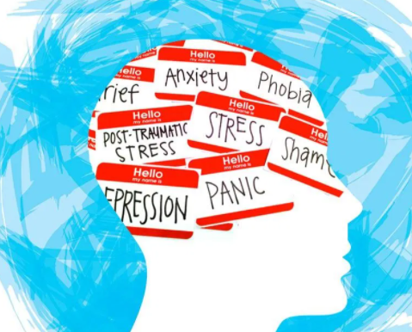

*Fig. 1.1 Illustration Image*

[2] Most people experience low mood at some stage. Clinical depression is so common that Seligman (1975) described it as the ‘common cold of psychiatry’ and perhaps depression is present, as a subsidiary difficulty in the majority of psychiatric conditions. It has been estimated that 3-4% of the population suffers from significant or clinical depression and between 13-20% suffer significant levels of depressive symptoms or dysthymia at any point in time. More than 12% of this total will require professional treatment.

Depression accounts for up to 75 % psychiatric hospitalizations. Prevalence rates amongst the various socio-economic, age related, gender and ethnic groups is a tortuous area too complex to enter into detail, but we may note that the rate of depression among women in Western industrialized countries is approximately twice the rate of men. For women depression is most common between 35-45 yrs. of age whilst with men incidence increases with age. Depression is more prevalent amongst divorced or separated persons and within socio-economic classes 1, 2 and 5.

## Relevance

Current treatments and dominant models of health care system do not adequately address the mental health care. Also, there is a stigma related and challenges faced by the individuals who need therapy. So, the AI Therapist system is aimed at creating an affordable and safe way for those who are seeking help.

**Chapter 2**

**Literature Survey**

**Chapter 2**

**Literature Survey**

**2.1 LITERATURE SURVEY**

|  |  |  |  |  |
| --- | --- | --- | --- | --- |
| **Sr.no** | **Author,Year of Publication and Publication** | **Paper Title** | **Advantage** | **Disadvantage** |
| 1. | Simon D’Alfonso, Olga Santesteban-Echarri ,Simon Rice, Greg Wadley , Reeva Lederman ,  Christopher Miles , John Gleeson and Mario Alvarez-Jimenez  02 June 2017 | Artificial Intelligence-Assisted Online  Social Therapy for Youth Mental Health. | Experimental  Researched therapy | Over Reliance and Self Diagnosis.  Mostly Expensive. |
| 2. | [Flávio Luis de Mello](https://www.ncbi.nlm.nih.gov/pubmed/?term=de%20Mello%20FL%5BAuthor%5D&cauthor=true&cauthor_uid=30804863), and [Sebastião Alves de Souza](https://www.ncbi.nlm.nih.gov/pubmed/?term=de%20Souza%20SA%5BAuthor%5D&cauthor=true&cauthor_uid=30804863)  11 February 2019 | Psychotherapy and Artificial Intelligence:  A Proposal for Alignment | Able to detect multiple disorders | Lack of experiment evidence.  Minimal Professional involvement. |
| 3. | Principles of medical ethics, an analysis of the ethical and social aspects of currently embodied AI applications    May 1999 | Principles of medical ethics, an analysis of the ethical and social aspects of currently embodied AI applications | Able to perform self-diagnosis | Focus on only one condition. |

**Table 2.1: - Literature Survey**

**2.2 EXISTING SYSTEM**

**WOEBOT**-

* It uses chat interference to gather the data to be processed.
* Its target users are patients and clinicians.
* It is built on the platform of Cognitive Behavioral Therapy (CBT) a process that the UK National Health Service describes as a talking therapy that can help patients manage mental health condition by changing the way they think and behave by enabling patients to reframe their negative thoughts into positive ones – natural language processing, clinical expertise, and light-hearted daily talk intended to create a therapeutic experience for the user.
* It is a conversational agent or chatbot that monitors the moods of users and provides a venue in which users can express their thoughts and emotions through therapeutic conversations.
* In a recent study conducted by Stanford University over a two-week period, 70 students aged 18-28 who had up to 20 sessions with Woebot reported significant decreases in their feelings of anxiety and depression, compared to an information-only control group.

## MOODKIT AND MOODNOTES-

* It uses Chat, video, text and voice journal to gather the data to be processed.
* Moodkit uses guided activities that identify and change negative thought patterns, tools that rate and chart moods across time, and text journaling using custom templates to help users alleviate symptoms of mental illness.
* Moodnotes claims to use CBT principles in guiding users in complete journaling activities. It works with users inputting their mood for the day, rating their mood, and providing a short description or some context about their emotion.

## PACIFICA-

* It uses audio and video to gather the data to be processed.
* The Pacifica app, is an app that can help address anxiety issues based on Cognitive Behavioral Therapy-based principles.
* Tools and activities include meditation, relaxation, mood and health tracking tools.
* The health tracker monitors habits that trigger anxiety such as exercise, sleep, caffeine, alcohol, etc., and, based on these, helps users to set goals that will improve their mood.

## WYSA-

* It uses chat interference to gather the data to be processed.
* Wysa is an AI-based ‘emotionally intelligent’ bot that helps users manage their emotions and thoughts.
* Tools and techniques such as evidence-based CBT, Dialectical Behavior Therapy (DBT), as well as guided meditation, breathing, and yoga are used.

### PROBLEM STATEMENT

Mental illness, also called mental health disorders, refers to a wide range of mental health conditions — disorders that affect your mood, thinking and behavior. Examples of mental illness include depression, anxiety disorders, schizophrenia, eating disorders and addictive behaviors. The current approach towards mental health includes several obstacle for people from various spectrum and people who want privacy. Our project ,aims to bridge this obstacles and hence improve the overall mental health. The solution proposes use of CBT to analyse the user’s frame of mind. DNN is going to be used to classify weighted words from the response of the user to pre-set questions. Using the Sentiment Analysis algorithm, our program detects how the user is feeling. He may be feeling depressed, feared, angry etc. Then a recommender system is used to show him content based on his current emotions.

# Chapter 3 Requirement Gathering

## Chapter 3

## Requirement Gathering

### 3.1 SOFTWARE AND HARDWARE REQUIREMENTS

Software Requirements: 1)Dialogflow

Hardware Requirements: 1) Processor – Intel Pentium IIIand above

2) Hard Disk – 1 GB

3) Memory – 2GB RAM

Platform: 1) Google Cloud Platform

# Chapter 4 Plan of the Project

## Chapter 4 Plan of the Project

### METHODOLOGY

The psychiatric evaluation and subsequent tentative therapy is done by using

techniques which include:

**I.** Gathering the input: This stage seeks to understand and map mental state

of the individual in order to study its process in accordance with the

transition phases of his/her mood. During this period, the most relevant

task for psychotherapeutic planning is the comprehension of the

structural pattern, which is composed of chatbot which asks relevant

questions and collect the required data.

**II.** Recognition of Patterns: The project uses DNN and to analyze the

patterns of mental state. Following are the steps:

First, a text is split into its basic components: tokens,

sentences, phrases, entities.

Then, each topic and related words are identified.

Finally, a sentiment score is assigned to each emotion

**III.** Therapy: According to the mental state report generated, the application

gives appropriate activities or perform the task accordingly which includes

a wide range of options ranging from therapeutic music etc.

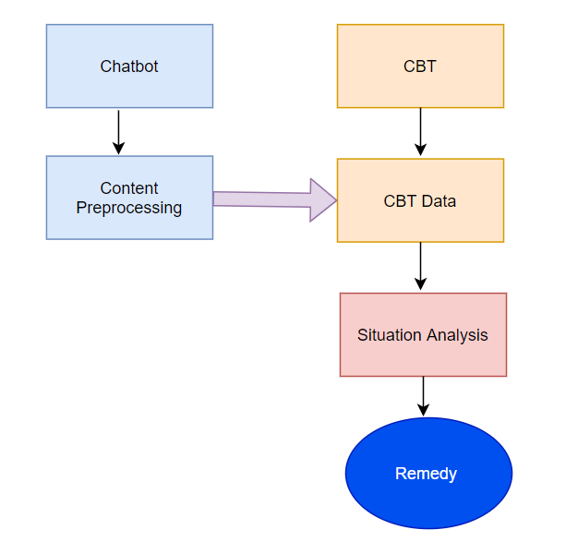

*Fig 4.1.1: Process*

### 4.1.1 ALGORITHM

For Classification, we used various algorithms to check the results and observe the algorithm which gives highest accuracy.

* **DNN**: DNN, or Natural Language Processing, is a branch of AI that helps computers read and understand natural human language. Its main goal is to improve human-machine communication
* **NLU**: NLU, or Natural Language Understanding, is a branch of DNN. It is all about machine reading comprehension and making sure the machine understands the text’s actual meaning. In more scientific terms, NLU takes place when the machine converts the user’s inputted data (what they’re saying) into a logical form that the computer's algorithms understand.

### 

### PROPOSED SYSTEM ARCHITECTURE

The architecture is divided in three main parts – Gathering Cognitive behavioral therapy data (Training Data), Collecting User’s responses (Testing Data), and Classification of weighted sentiments. The system Architecture is shown below. The system consists of 2 different datasets - Developer provided and User provided data for Training and Testing purpose, respectively. The training data is the data we will provide based on CBT while Testing data is the one, we will extract from the responses given by the user to the asked questions. We will use training data to train our model and our classifier will test it of Test data we extracted. A pre-processing is needed to be done on both the datasets before we use them. We use DNN to get the responses from the user for the testing data. After applying the Sentiment analysis algorithm on the Test dataset i.e. responses by user to particular questions, we get the weighted sentiments which gives an idea about the user’s frame of mind. Then the system will suggest some tentative remedies.

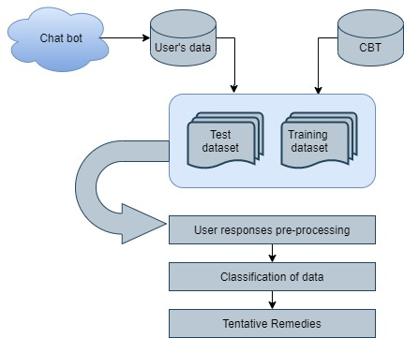

*Fig 4.2: System Architecture*

### 4.3 PROJECT PLAN (GANTT CHART)

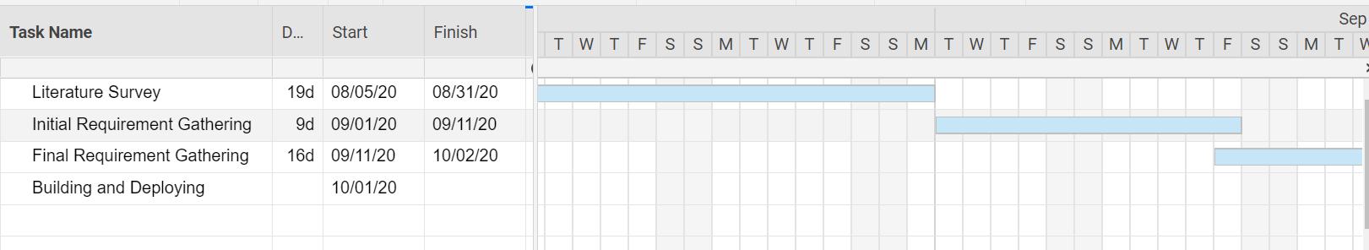

**Chapter 5**

**Project Analysis**

**Chapter 5**

**Project Analysis**

#### USE CASE DIAGRAM

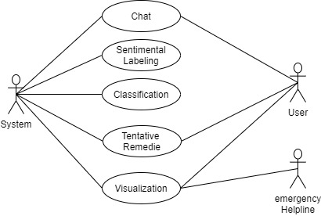

*Fig: 5.1 Use Case diagram*

* + 1. **Use Case Document**

A use case diagram at its simplest is a representation of a user's interaction with the system and depicting the specifications of a use case. A use case diagram can portray the different types of users of a system and the various ways that they interact with the system. This type of diagram is typically used in conjunction with the textual use case and will often be accompanied by other types of diagrams as well.

### USE CASE ANALYSIS

* + - 1. **Actor**

An actor is a person or other entity external to the software system being specified who interacts with the system and performs use cases to accomplish tasks. Different actors often correspond to different user classes, or roles, identified from the customer community that will use the product. The actors which are used in this use case are a robot and railway authority**.**

### Description

### This use case shows the interaction between the user and the chatbot and how they are co-dependent on each other. When the chatbot starts it’s conversation with the user it observes the individual thoughts and emotions; identify how situations, thoughts, and behaviors influence emotions; and improve feelings by changing dysfunctional thoughts and behaviors. If any suicidal thought is detected, one’s location is updated in a database where an emergency helpline can check and take necessary actions.

### 

### 5.2 SEQUENCE DIAGRAM

Sequence Diagrams are interaction diagrams that detail how operations are carried out. They capture the interaction between objects in the context of a collaboration. Sequence Diagrams are time focus and they show the order of the interaction visually by using the vertical axis of the diagram to represent time what messages are sent and when.

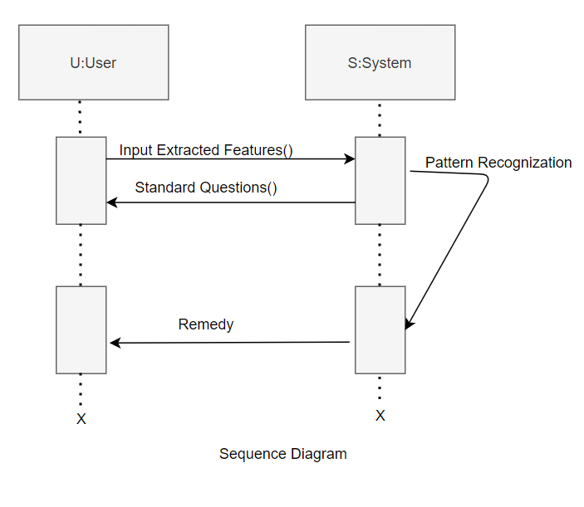

*Fig: 5.2 Sequence diagram*

**Chapter 6 Project Design**

**Chapter 6**

**Design Model**

### 

* 1. **DATA FLOW DIAGRAM:**

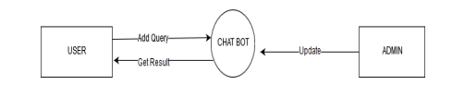

*Fig:6.1.1 Level Zero DFD*

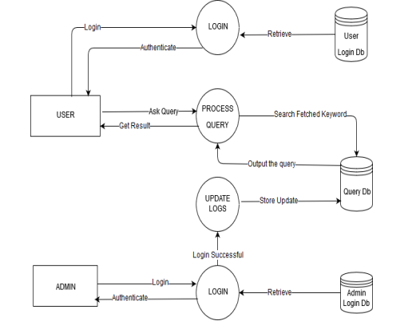

*Fig:6.1.2 First level DFD*

## RESULTS

This section will give us the results we achieved after applying testing the algorithms. First, with the data from users we extracted following are the types of emotions we were able to classify as we labelled them . Looking at the results (Fig. 4), we found that 58.57 percent of the users suffered from depression . Whereas, 28.28 percent of users were addicted to some substances like tobacco, alcohol, drugs.

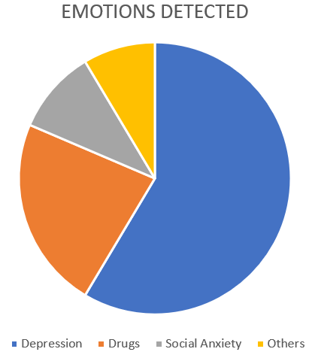

*Fig. 7.1. Classification Results Following*

A. Accuracy

We chose three different classifier algorithms - Naive Bayes, SVM and Random Forest classification Algorithms and check for the accuracy of the results. We received the Accuracy score of 88.889

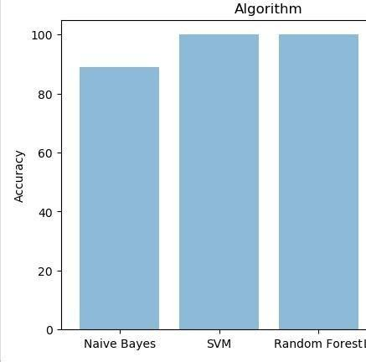

Fig. 7.2 Classification Result

from Naïve Bayes Algorithm with recall and F1 score of 0.875 and 0.8831168831 respectively. While both SVM and Random Forest showed same accuracy of 100 with recall and F2 score of 1.0 and 1.0 respectively.

## CONCLUSION

This paper shows the methods that are being used to combat mental health issues with minimum human assistance. The proposed system uses cognitive behavioral therapy to understand the frame of mind and guide the patient to a better psychological perspective by help of the chatbot, which takes text input from the users and provides an appropriate response. We effectively train the model with training dataset by first removing all the irrelevant information and then using DNN (Deep Neural Network) as a feature extracting data into more creative and abstract components. This makes it easy to detect the emotion a person is going through, a number of categories are also classified. We used DNN, Random forest and Naive bayes algorithms.

## REFERENCES

[1]Simon D’Alfonso, Olga Santesteban-Echarri ,Simon Rice, Greg Wadley , Reeva Lederman ,Christopher Miles , John Gleeson and Mario Alvarez-Jimenez on 02 June 2017 in “Artificial Intelligence-Assisted Online Social Therapy for Youth Mental Health.” https://www.frontiersin.org/articles/10.3389/fpsyg.2017.00796/full

[2]Flávio Luis de Mello, and Sebastião Alves de Souza on 11 February 2019 in ”Psychotherapy and Artificial Intelligence:A Proposal for Alignment” https://www.frontiersin.org/articles/10.3389/fpsyg.2019.00263/full

[3]Amelia Fiske, Peter Henningsen, Alena Buyx in “Your Robot Therapist Will See You Now: Ethical Implications of Embodied Artificial Intelligence in Psychiatry, Psychology, and Psychotherapy” https://www.jmir.org/2019/5/e13216

[4]“The Efficacy of Cognitive Behavioral Therapy: A Review of Meta-analyses” [Stefan G. Hofmann](https://www.ncbi.nlm.nih.gov/pubmed/?term=Hofmann%20SG%5BAuthor%5D&cauthor=true&cauthor_uid=23459093), Ph.D., [Anu Asnaani](https://www.ncbi.nlm.nih.gov/pubmed/?term=Asnaani%20A%5BAuthor%5D&cauthor=true&cauthor_uid=23459093), M.A.,[ImkeJ.J.Vonk](https://www.ncbi.nlm.nih.gov/pubmed/?term=Vonk%20IJ%5BAuthor%5D&cauthor=true&cauthor_uid=23459093),M.A.,AliceT.Sawyer, M.A., and Angela Fang, M.A. https://www.ncbi.nlm.nih.gov/pmc/articles/PMC3584580/

[5]Aaron T.Beck “Cognitive therapy: Nature and relation to behavior therapy**”** https://www.sciencedirect.com/science/article/abs/pii/S0005789470800302

[6]MJ Peebles Beginnings: The art and science of planning psychotherapy.